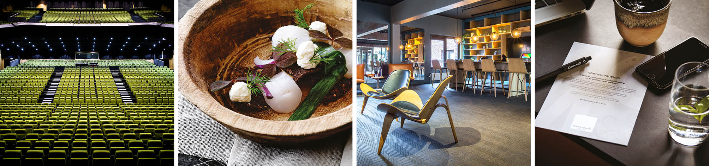

Reg.: European Robotics Forum 2023

Dear exhibitor

For us to prepair your arrival and give you the best start, please fill in this form and return it, also if you do not have any requests.

Important: Please return the form by e-mail to Dorthe Kramer at dokr@comwell.com
no later than February 13th 2023

Exhibition area: You have access to your stand on March 13th 2023 from _08:00____________.
Removal of the stands must be finish on March 16th at ___20:00____________.
Please refer to https://erf2023.sdu.dk/sponsor-and-or-exhibitor-agreement/

Materials: Must be sent to:
ODEON
Odeons Kvarter 1
5000 Odense C
Ref. ERF 2023/Your company/Both number/att: Dorthe Kramer

Storage: It is possible to store minor materials for the stand 1 day prior to the event. Please make sure that the materials are picked up again on March 17th between 8 am and 3 pm. Storage of minor materials other than the above mentioned will cost DKK 695.- per day. Storage of larger items is not possible without prior agreement.

Food & Beverage: It is not allowed to bring your own food and drinks. Comwell has the exclusive right to sell food and beverages to both exhibitors and guests. If exhibitors wish to hand out tastings at the stand, this must be agreed separately with Comwell, and the exhibitor is responsible for following Danish legislation in the food area, e.g. documented self-inspection at the stand and proper disposal of waste. In connection with organic waste, the tenant must plan and consider the following: overview of delivery, quantity, handling, storage and disposal, extra cleaning before, during and after the event, etc.
Comwell is entitled to charge a tasting fee.

Parking: There is parking at Comwell H.C. Andersen Odense, Claus Bergs Gade 7.
Both indoor and outdoor parking against parking fee - rember to register you car in the parkinglot for payment in order to avoid fines.

Internet: We offer you free Internet, please find Comwellhotels, password Comwellhotels

Questions: Please contact us per mail: dokr@comwell.com

We look forward to welcoming you to Comwell H. C. Andersen/Odeon.

Kind regards

Comwell H.C. Andersen/ODEON Odense

Form for: ERF 2023 March 14th – 16th
Ware | Number | Price DKK | Comment
Bowl of candy |  | 75.- | Time?
Bowl of snacks |  | 75.- | Time?
Per soft drink |  | 41.- | Time?
White table cloth |  | 40.-
Conference hign table |  | Incl.
Extension cord 5m  3-socket (extra) |  | 100.-
Bouquet incl. vase: |  | from 450.- | Colour/price?
Small glass bowl |  | 30.-
Large glass bowl |  | 50.-
Other request

Both number:

Please note: The above mentioned rates are only applicable when preordered and prepaid. Orders on the same day as the event: The rate will increase with 50 % and payment upon ordering

Invoice address:

___________________________________________________________________________
___________________________________________________________________________

CVR & EAN:_____________________________________________Tel. _________________

Mail:____________________________________Contact person:_______________________

